Coffee and a Gas
A wellbeing initiative from Association of Anaesthetists Trainees

Conversations are important to help us share our experiences and reduce stress levels. Take a moment to catch up with colleagues over a coffee.

The next Coffee and a Gas is:

When:
Where:
Anything else:

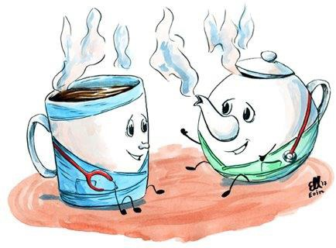
#CoffeeandaGas

More resources and support available at
www.anaesthetists.org/wellbeing

