Instructions for use
The QRH is intended for use by individuals who are familiar with it and who are practised in its use. See www.aagbi.org/qrh for further details on implementation.

Each guideline follows the same format:
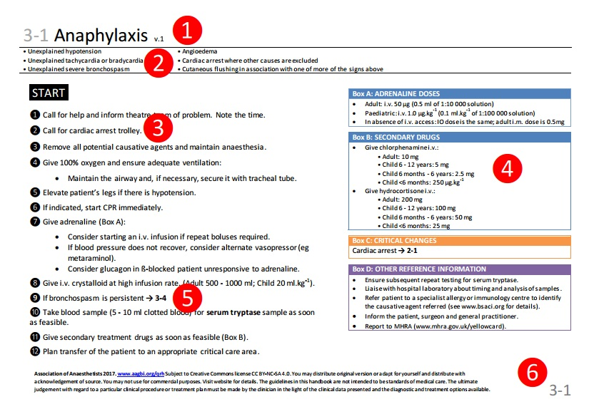
- Guideline number, name and version number.
- A brief description of the clinical situation for which the guideline is written.
- The body of the guideline.
- Call out boxes, which may be referred to in the body text.
  - Orange = critical changes
  - Blue = drug doses
  - Green = CPR information
  - Black = equipment instructions
  - Purple = other reference information
- A guideline may suggest changing to one of the other guidelines, like this: → 2-1
- The guideline number is repeated for easy finding without need for a tabbed folder.

Each guideline should be used in the same simple way.
- Start at START.
- Work through the numbered bullet points in order.
- Where indicated, refer to the call out boxes on the right.
- Where indicated, move to another guideline.

We recommend:
- One person should read the guideline aloud; they should NOT also be the person performing the actions.
- The reader should ensure that the guideline is followed systematically, thoroughly and completely and that steps are not omitted.
- Whenever experienced help arrives, consider delegating leadership to them: they have a fresh pair of eyes and may be able to make a more clear-headed assessment.

